Chapter 6 Magnetic field and EMF
Chapter Test Answers Total marks 47

Question 1
A student sets up the equipment shown below to conduct an experiment to measure the change in current when a magnet is moved in and out of the wire coil. The student sets up the magnet to move in and out of the coil at a constant rate and measures the current on the ammeter.

- On the axes below, sketch a graph of current versus time to show how the current will vary as it is moved in and out for one cycle (i.e. from 0 to t seconds the magnet moves all the way in and from t to 2t seconds it moves completely out of the field.) Label the axes and significant points on the axes. (4 marks)

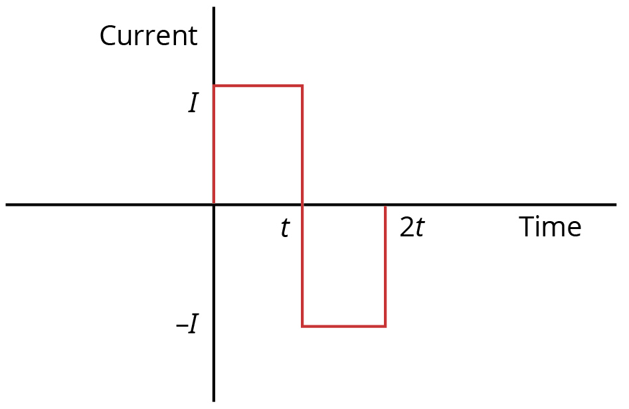

Description | Marks
Shape of graph | 1
Current and time axes labelled | 1
Time scale for t and 2t appropriate | 1
Positive and negative current of equal magnitude | 1

- On the coil, draw arrows to show the direction of the induced current when the magnet is moving to the left. (1 mark)

Description | Marks
Current in wire on right shown going up | 1

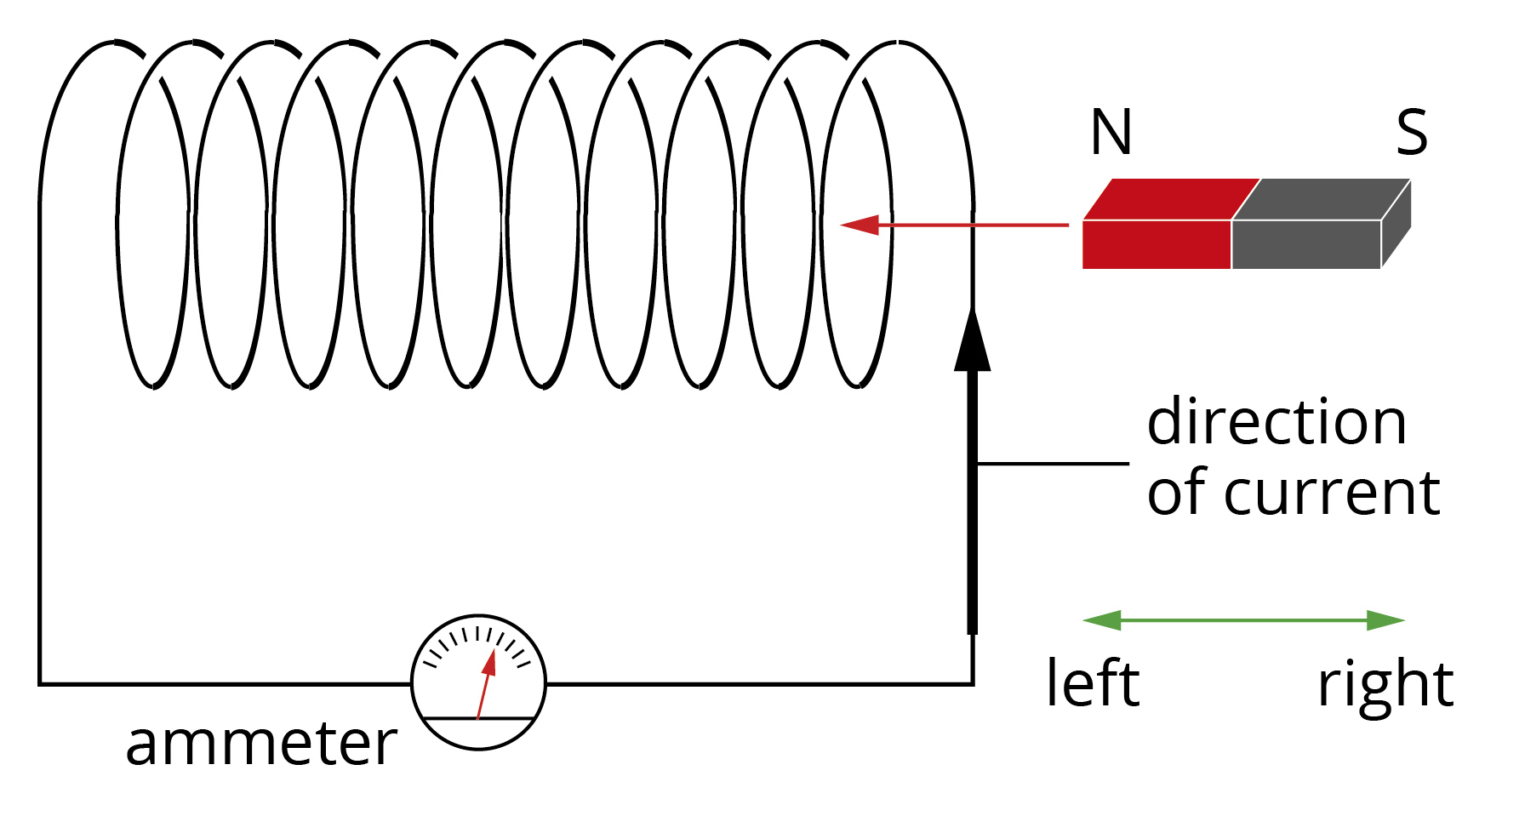
- If the magnet was turned around the other way for a second trial, how would the induced current compare to the original trial? Assume the rate at which the magnet moves in and out of the field is the same in both trials. (2 marks)

Description | Marks
Recognition of reversal of current direction; in trial 2 the direction of the current going in would be the reverse of the direction it was when going into the coil for trial 1 (similarly when going out of the coil) | 1
Magnitude of current would be the same in both trials | 1

Question 2
In an experiment to determine the strength of the magnetic field in his location a scientist attaches a rigid 5.00 m aluminium pole to the top of a car so that the pole is horizontal and oriented in a north-south direction. The car is travelling at a constant velocity of 60 km h⁻¹ towards the east. The ends of the pole are attached to wires that lead to a voltmeter, which gives a reading of 6.42 mV.
- Calculate the strength of the vertical component of the earth’s magnetic field at this location. (4 marks)

Description | Marks
EMF = ℓvB | 1
v = 60 km h⁻¹ = 16.67 m s⁻¹ | 1
 | 1
 | 1

- Which end of the aluminium pole has a negative potential? (1 mark)

Description | Marks
South end | 1
Question 3
A model village has 15 electrical components, each rated as 6 V and 0.5 A, connected in series. The model’s circuit is connected to the secondary coil of an iron core transformer that has a 1000-turn primary coil. The primary coil is connected to the
240 V 50 Hz mains supply.

- What total voltage will the circuit need to have supplied to operate the
15 components? (1 mark)

Description | Marks
V_{total} = 15 × 6 = 90 V | 1

- What is the number of turns in the secondary coil of the transformer? (2 marks)

Description | Marks
 | 1
 | 1

- Determine the power being supplied by the secondary coil. (2 marks)

Description | Marks
P = VI | 1
P = 90 × 0.5 = 45 W | 1
- If the transformer has an efficiency of 85%, find the power supplied by the primary coil of the transformer. (2 marks)
Description | Marks
 | 1
 | 1

- What may cause the loss of power from the primary coil to the secondary coil and suggest how may this problem may be reduced? (2 marks)

Description | Marks
Heating due to eddy currents causes power loss | 1
Using thin laminated plates for the iron core of the transformer will reduce the extent of the eddy currents | 1

Question 4
A drone helicopter with metal rotor blades of length 15 cm from axis to tip is flying in Perth, where the vertical component of the Earth’s magnetic field is approximately
5 × 10⁻⁵ T upwards.
- What is the magnetic flux due to the Earth’s magnetic field that passes through the area swept out by the rotor blades? (3 marks)

Description | Marks
 | 1
 | 1
 | 1

- If the rotor spins at 10 revolutions per second, what is the magnitude of the EMF induced between the axis and the tip of the rotor blade due to its rotation in the Earth’s magnetic field? (3 marks)
Description | Marks
 | 1
 | 1
 | 1

Question 5
The efficiency of all motors is reduced by a problem known as ‘back EMF’. This is the phenomenon where an EMF develops in the armature coils of the motor. Briefly explain why a motor will generate a current and why it reduces the efficiency of the motor.
(3 marks)
Description | Marks
An electric motor has wire coils rotating in a magnetic field (i.e. a conductor experiencing a changing flux)—the conditions required for an EMF to develop | 1
The induced current will create a magnetic field opposing the changing field responsible for inducing the current (Lenz’s law) | 1
Thus, the induced current will be in the opposite direction to the applied current, reducing the motor’s efficiency | 1

Question 6
An engineer was testing a new generator for a wind turbine. The turbine was placed in a wind tunnel, connected to the generator, and the voltage produced over time was measured. The generator consisted of a coil of 5000 turns and radius 50 cm. The graph below shows the results of these measurements.
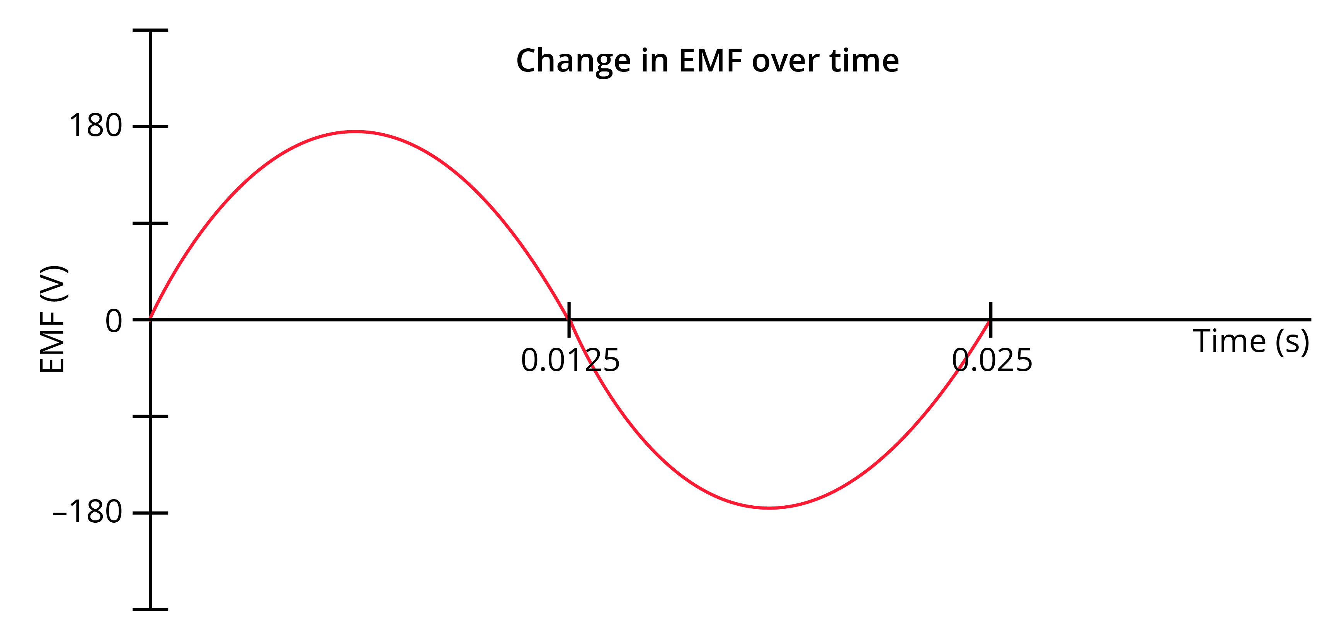

- What is the frequency with which the generator rotates? (1 mark)

Description | Marks
 | 1

- What is the strength of the magnetic field used in this generator? (5 marks)

Description | Marks
EMF_{max} = −2𝜋NBAf | 1
 | 1
From graph, EMF_{max} = 180 V | 1
 | 2

- What is the root mean square average EMF produced by the turbine? (2 marks)

Description | Marks
 | 1
 | 1

- The engineer adjusts the wind speed in the wind tunnel and alters the gearing on the turbine so that the generator rotates with twice the frequency as originally. Sketch a graph of how EMF varies with time under these new conditions. (2 marks)

Description | Marks
Recognition of two cycles in the same time as in the original | 1
Maximum EMF 360 V | 1
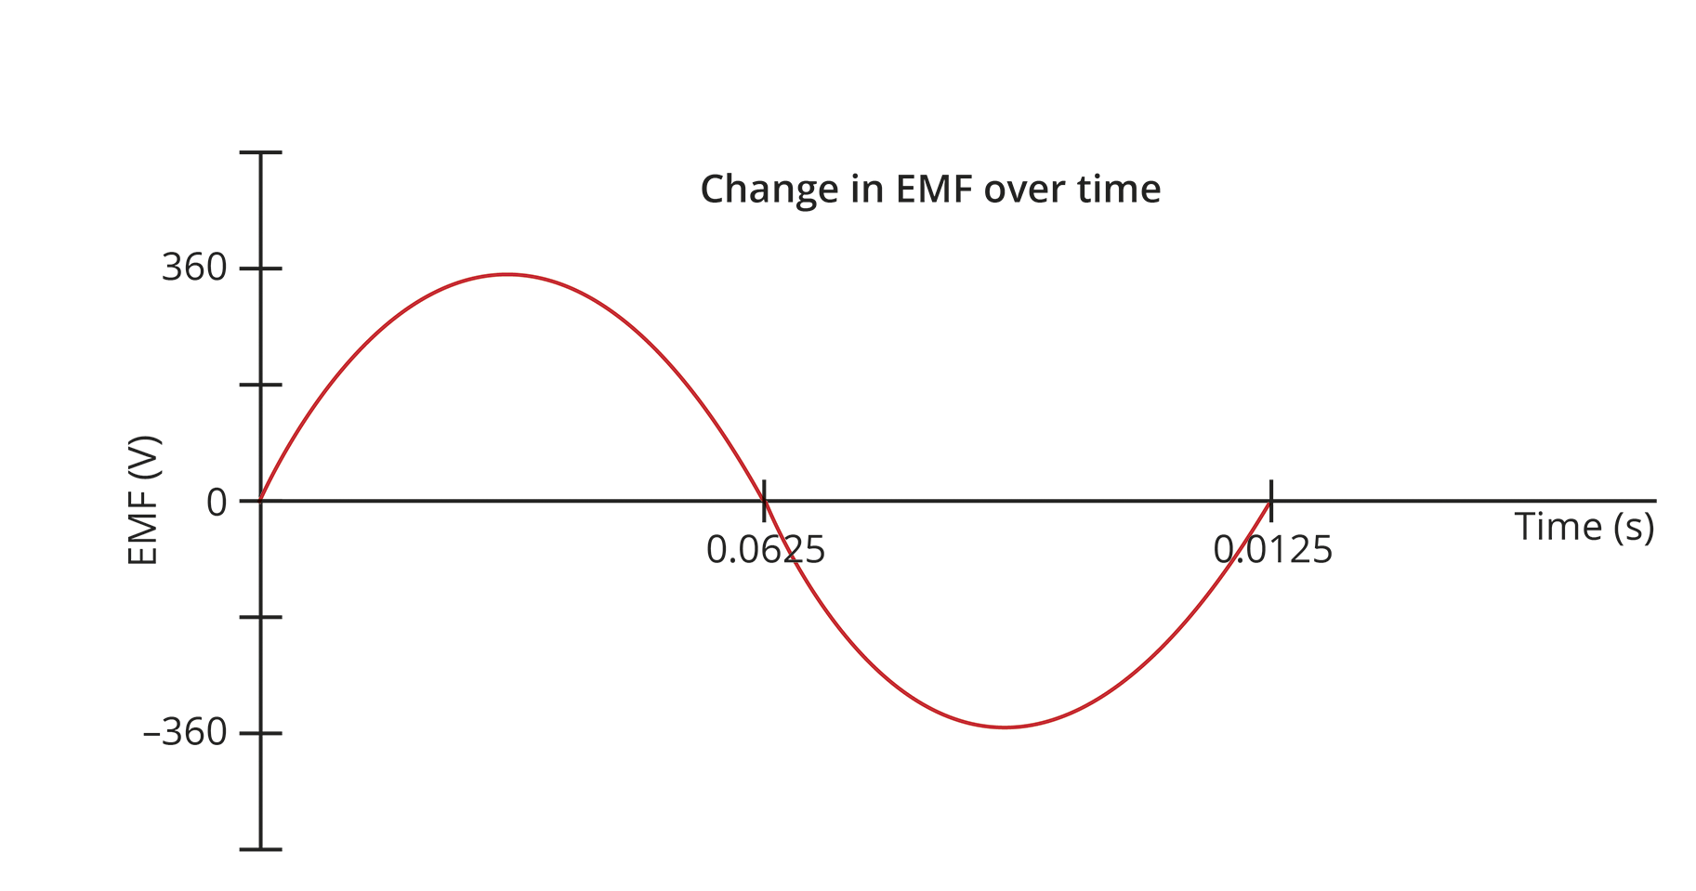

- Identify three changes the engineer can make to the design of the generator to increase the maximum EMF produced by it. (3 marks)

Description | Marks
Increase number of turns in coil | 1
Increase radius of armature | 1
Increase strength of magnetic field | 1

Question 7
The Kwinana Power Station in Naval Base, Western Australia, has a generating capacity of 420 MW. The power station is located long distances from the homes to which it supplies power, and it is not practical to send the current along wires at 240 V (the voltage directly used in the home) as this would lead to large power losses in the wires carrying the current. Instead the power station has 66 000 V, 132 000 V and 330 000 V transmission lines to the South West Interconnected System.

- Explain why there would be large losses if the power where to be supplied at 240 V? Include in your answer any mathematical relationships that are relevant. (2 marks)

Description | Marks
If the 420 MW of power were supplied at 240 V, this would lead to a very large current. | 1
Power losses would then be high due to: | 1

- Suggest a reason why there are three transmission lines to the South West Interconnected System of 66 000 V, 132 000 V and 330 000 V. (2 marks)

Description | Marks
The differences in transmission voltages are likely due to differences in the distances the current travels. The lower voltage transmission is for a shorter distance so there is less power loss, while the greater distance to travel the more potential there is for power loss. | 1
To reduce power loss over longer distance, it is transmitted at higher voltages to reduce the transmission current. | 1

